**Day 5 - 28/5/2025**

**Barghavi Bethu   
112728766 - bethubal**

**Task 1:**

Create a Directory with the Name Linux Practice.

**Task2:**

Change to the directory.

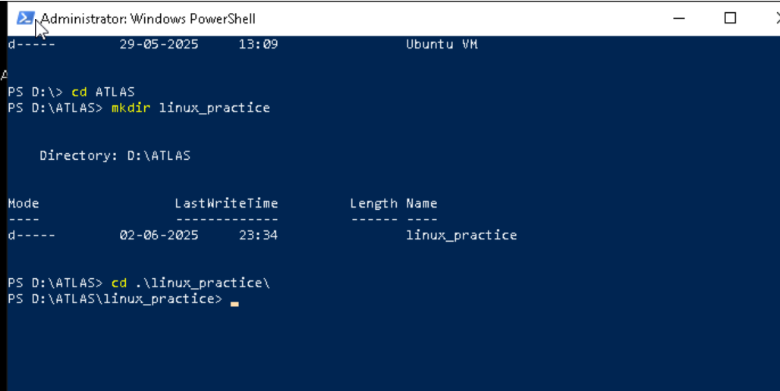

**Task 3:**

Create a file names TestFile1.txt and add the content to it.

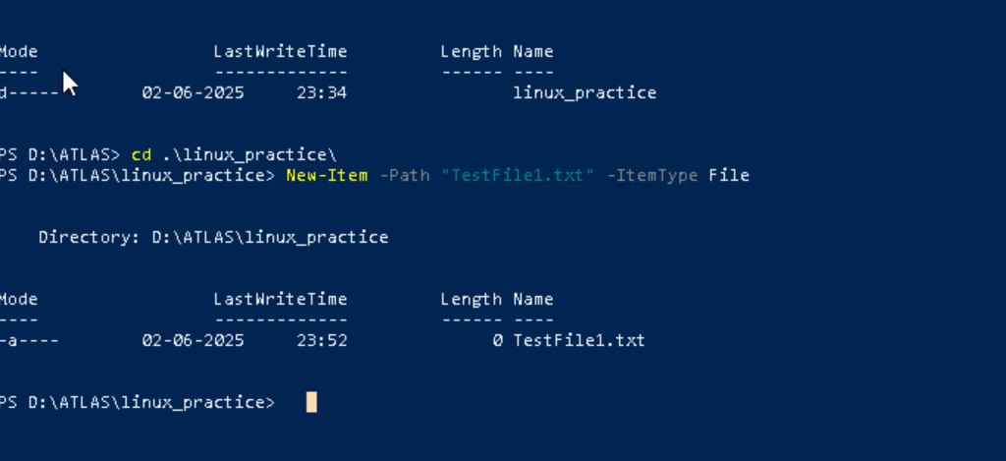

**Task 4:**

Create a Folder named Dummy and try to delete it.

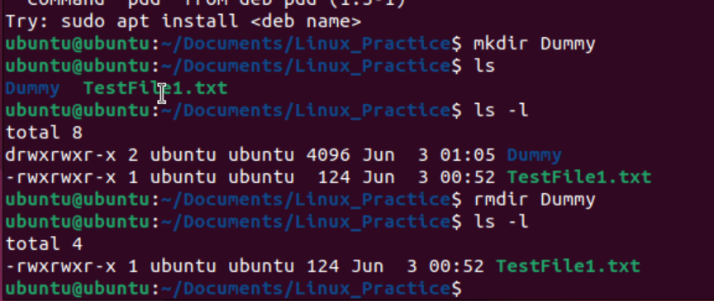

**Task 5:**

Plz check the working directory (Hint : pwd)



**Task 6:**

How do you check all the files and directories in the directory you are in?

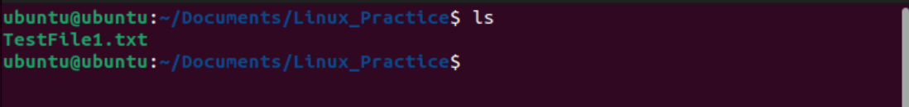

**Task 7:**

Create five files named TestFile2.txt.. TestFile3.txt… and so on till TestFile6.tx

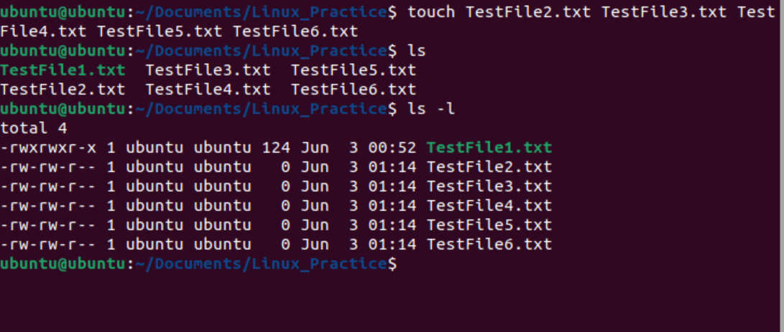

**Task 8:**

Copy all files from Dir 1 to Dir 2

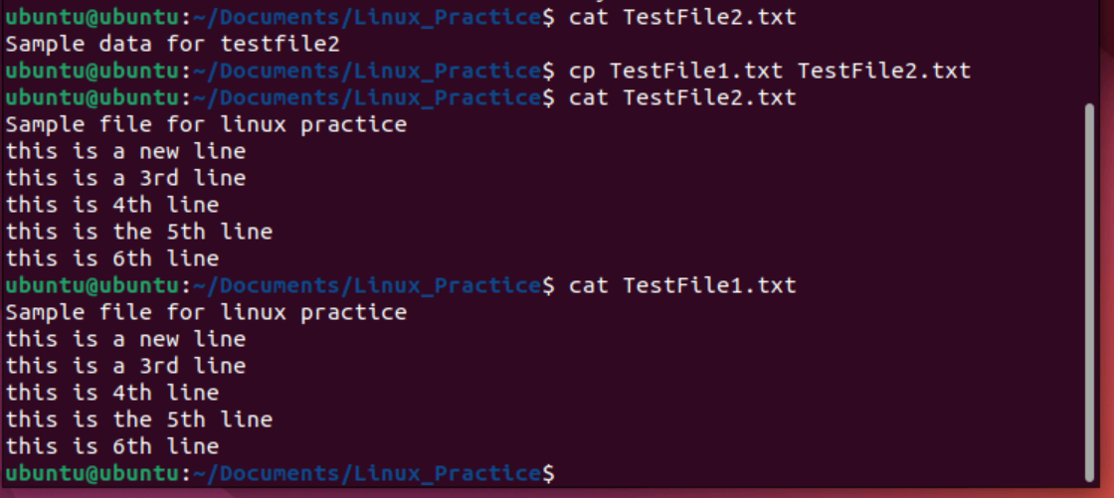

**Task 9:**

Move all files from Dir 2 to Dir 3 (finally ur Dir 2 should be empty)

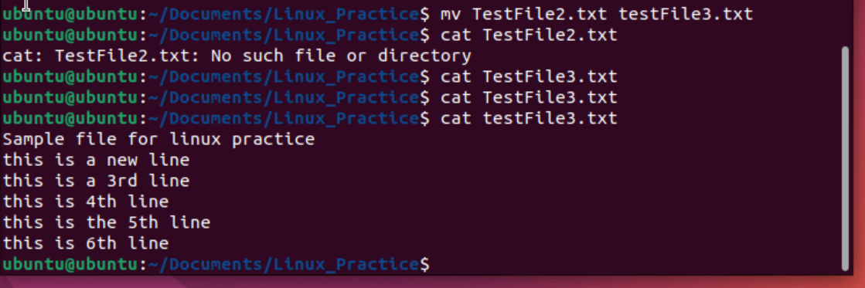

**Task 10:**  
Can you plz show me the diff between rm and rmdir commands with screen shots?

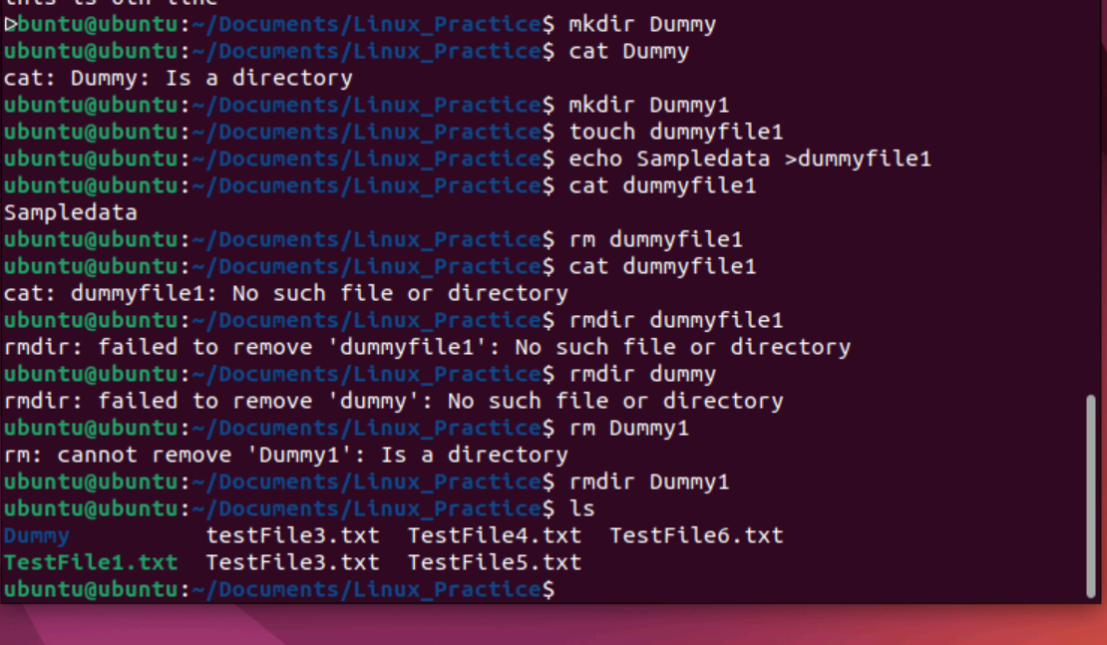

**Task 11:**

Now use specifically use cat command to create a file

And add the dummy text of 2 to 3 paragraphs from the above link Lorem Ipsum.

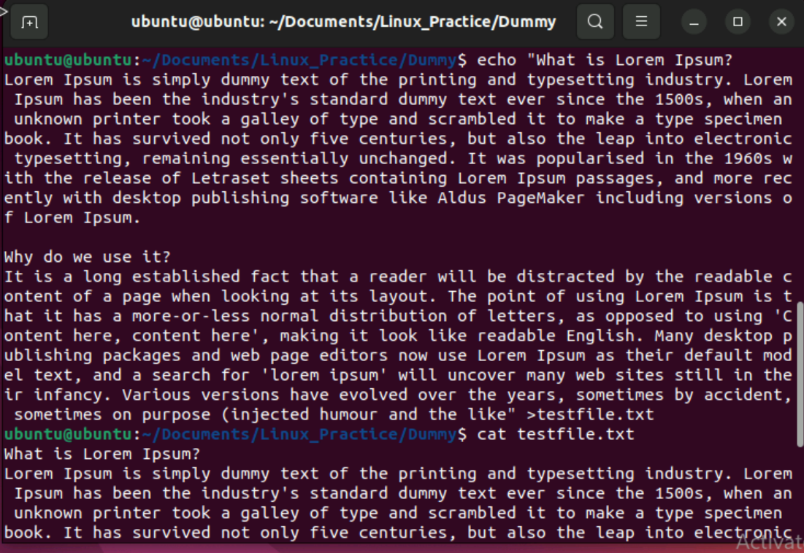

**Task 12:**

How to get only the top part of your file..

Hint: use head

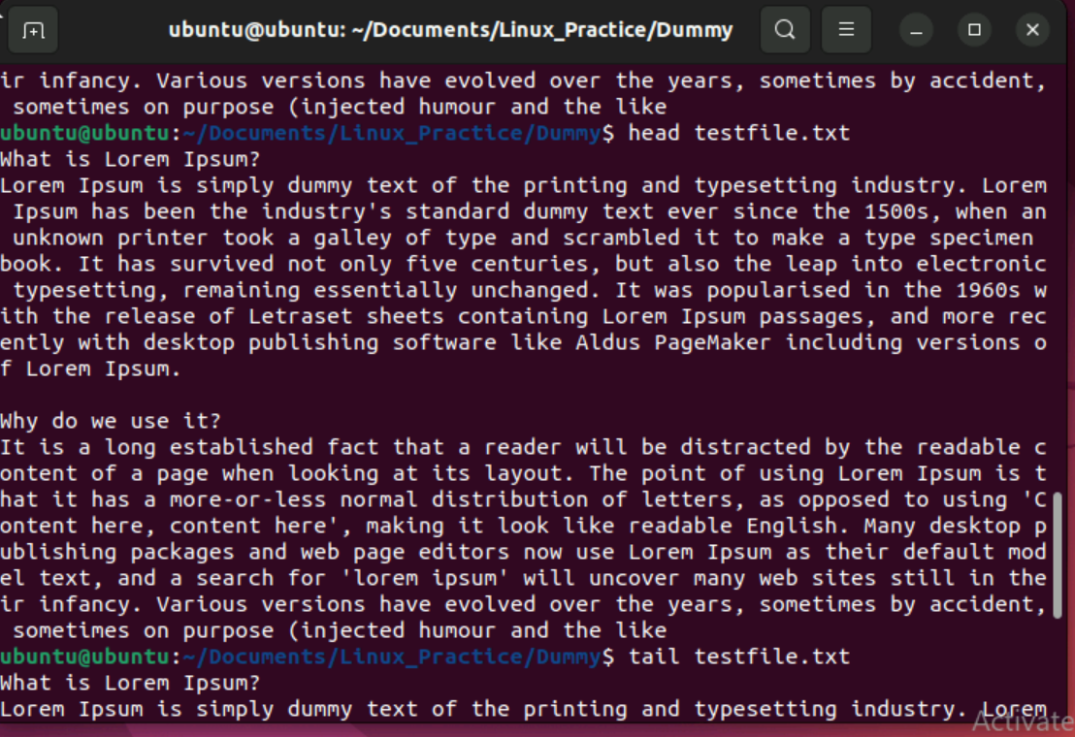

**Task 13:**

How to get only the last part of your file

Hint: use tail

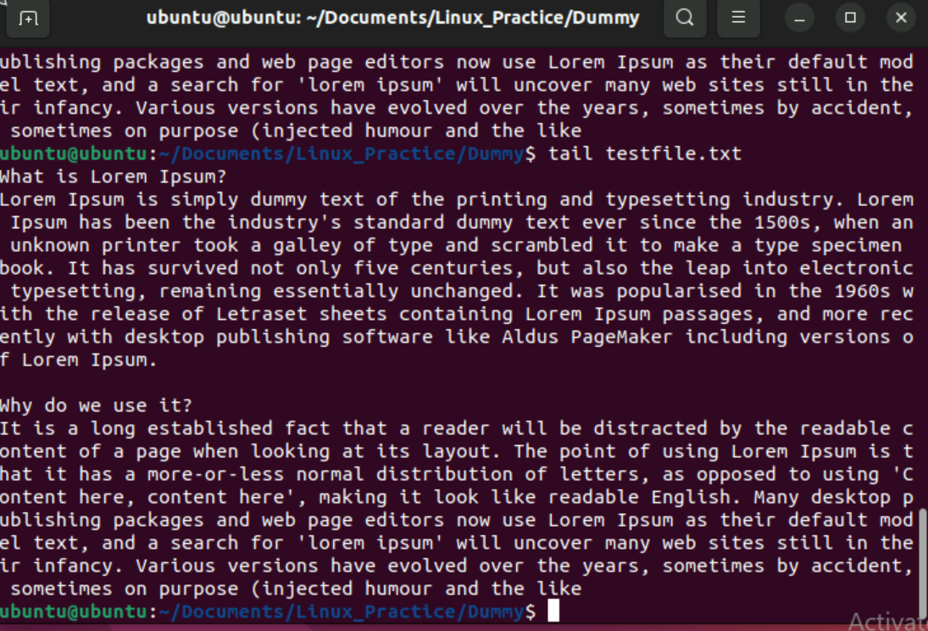

**Task 14:**

Plz add dummy text of 5 to 6 pages in to the same file And Now show the file in page by page

Hint : use less command

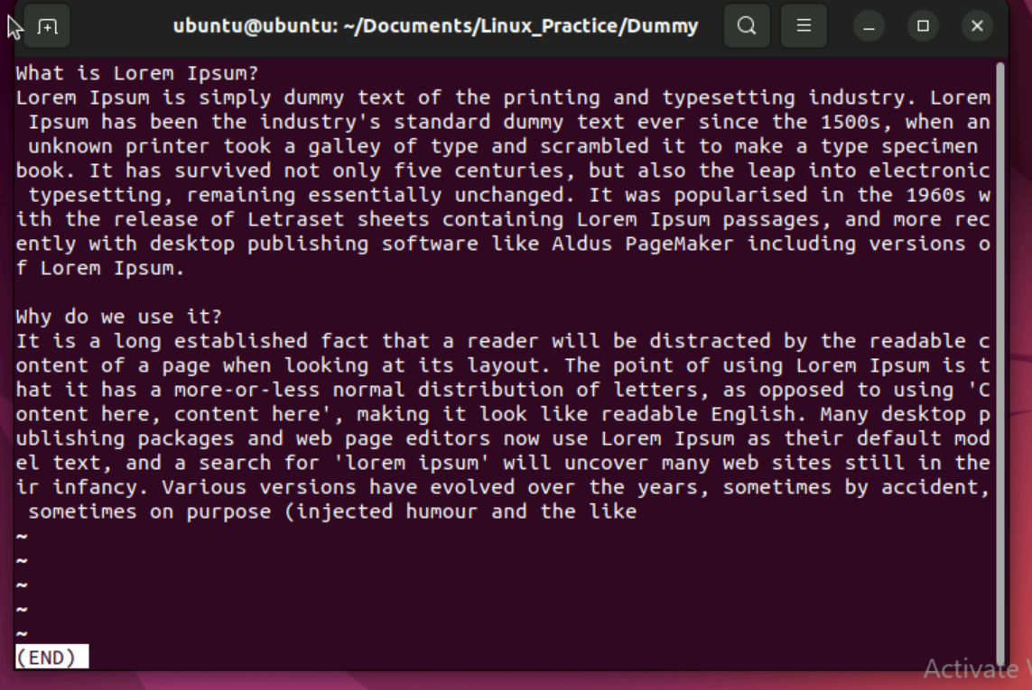

**Task 15:**

Use more command on the above file and find out the diff between less command and more command.

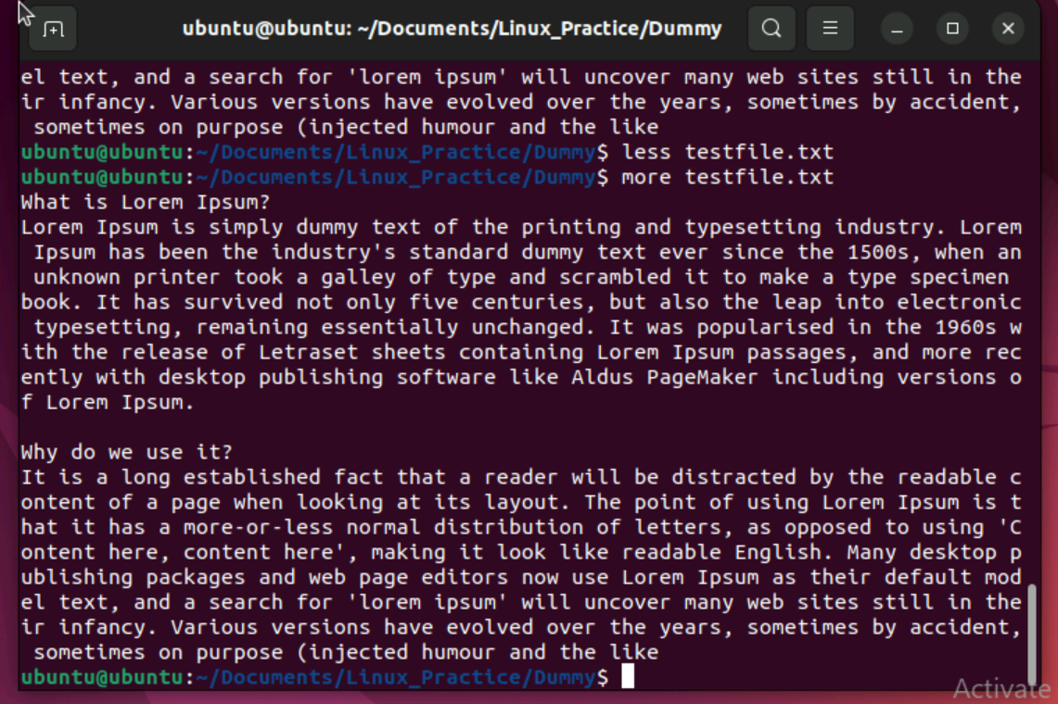

Less command is used to show file in a page by page manner

More command used to see all the content in the terminal.

**Task 16:**

Can you use echo command with -e and see the diff.. Also take a ss and paste .

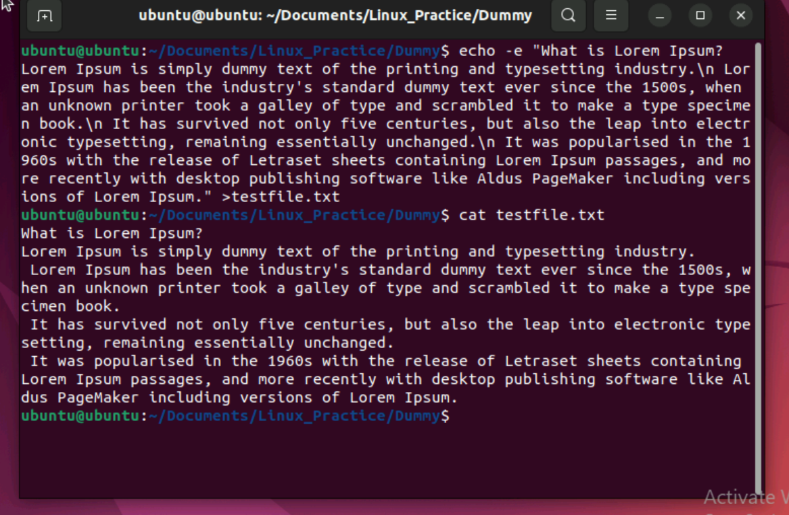

**Task 17:**

What is diff between ls and ls -l command .. ss plz

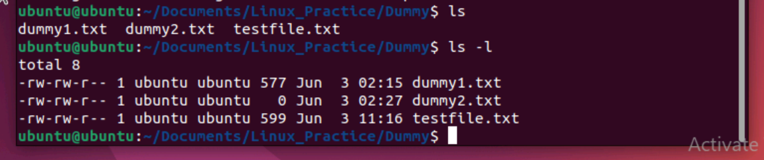

**Task 18:**

Create  a file using touch command , cat command and echo command and take ss (screen shot).. Also write the difference between touch , cat and echo commands.

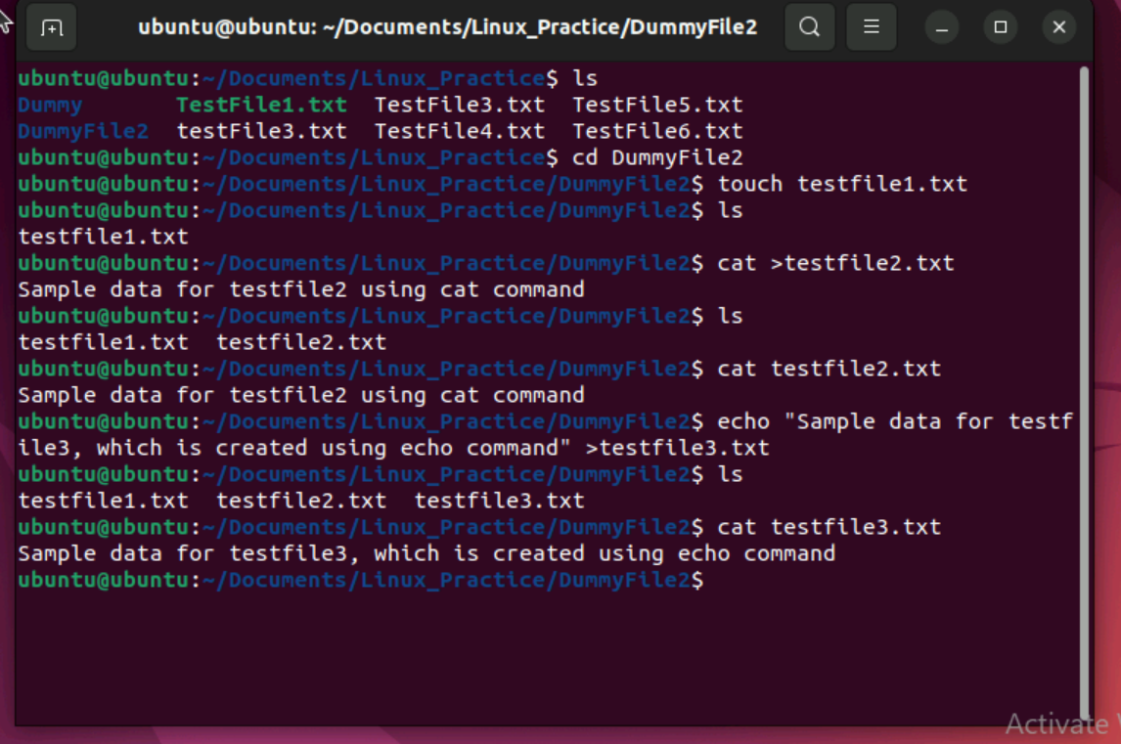

Using touch command we can create a new file.

touch filename

Cat command is used to check the output data present in the existing file or also we can create new with along with inserting data at the same time.

cat >file name

enter data into file and press ctrl+d to save the file

cat filename to check data in file

Echo command is used to provide input data into a file. We can also simultaneously create a file and enter data at same time using echo command.

echo “enter text” >filename

**Task 19:**

Can you guys try to display the calendar by using a command.

Hint: use cal

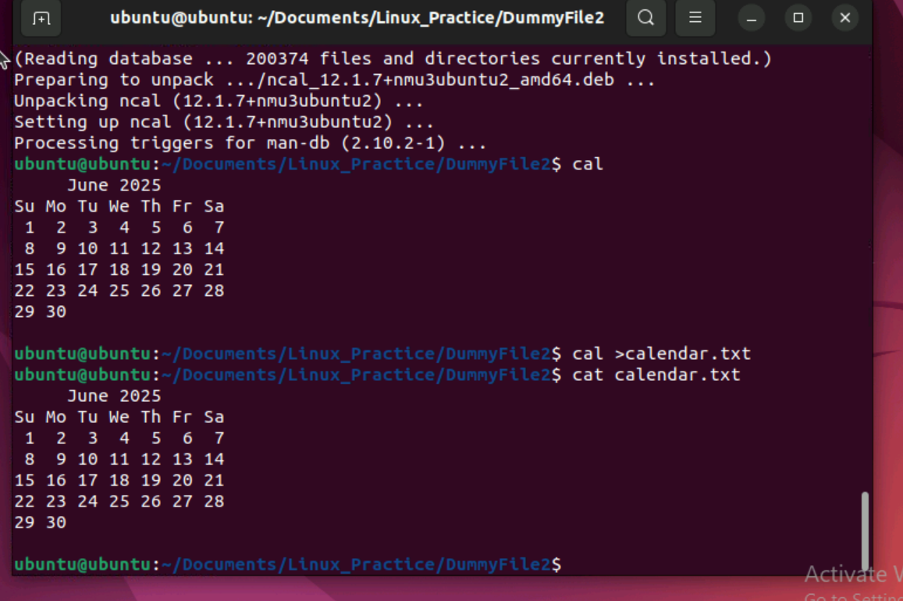

**Task 20:**

Can you go back to 1 directory .. at a time  whats the command

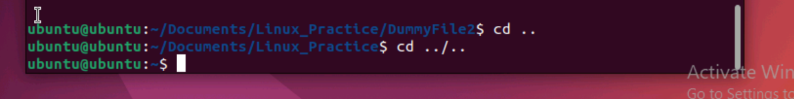

**Task 21:**

How to know whose user u are working on ?

Hint: use whoami command

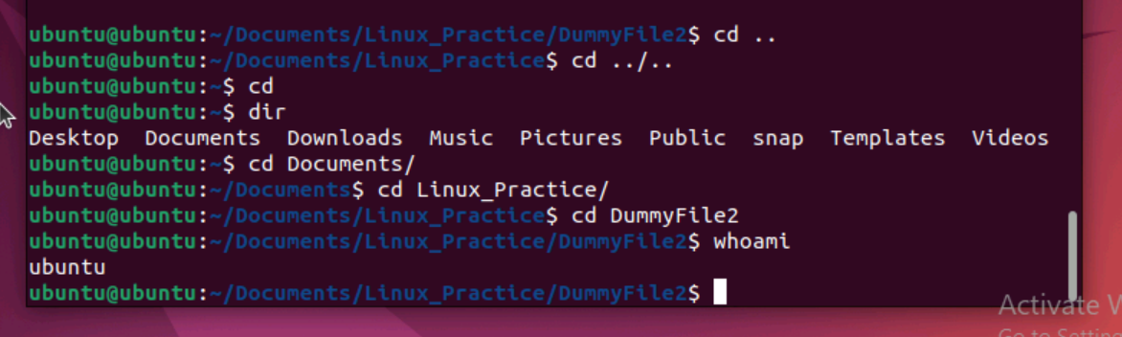

**Task 22:**

Try to find out who is peeping into your system..

Use users, who and w commands with ss

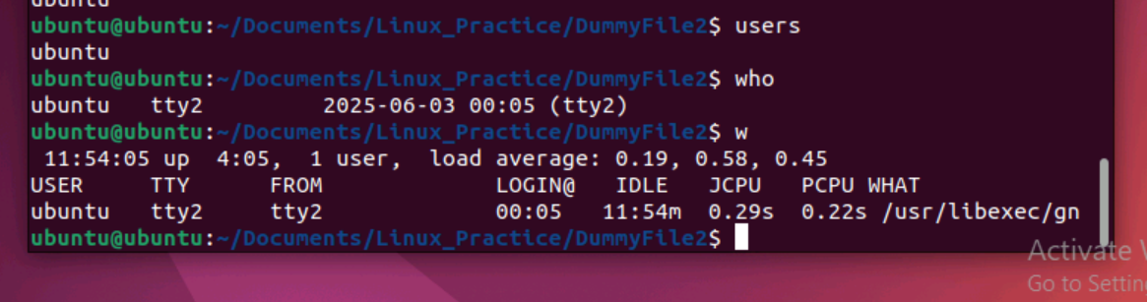

**Task 23:**

Can you guys try to check how much disk space is consumed..

Hint : use df -h

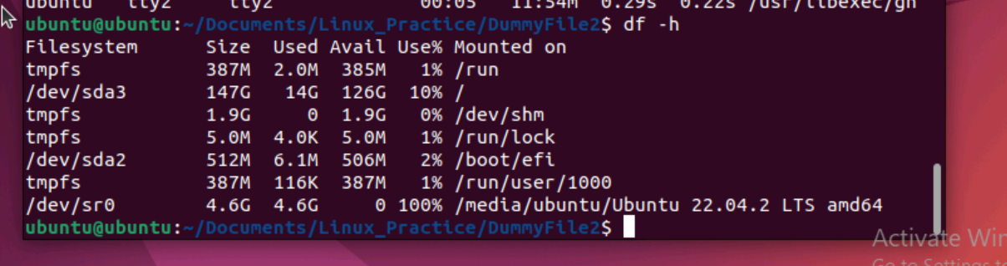

**Task 24:**

Can you plz try using the below commands

|  |  |
| --- | --- |
| Prefix | Description |
| - | Regular file, such as an ASCII text file, binary executable, or hard link. |
| b | Block special file. Block input/output device file such as a physical hard drive. |
| c | Character special file. Raw input/output device file such as a physical hard drive. |
| d | Directory which contains a listing of other files and directories. |
| l | Symbolic link file. Links on any regular file. |
| p | Named pipe. A mechanism for interprocess communications. |
| s | Socket which is used for interprocess communication. |

**Task 25:**

Find the list of all files ending with .txt

Hint : use * in ls

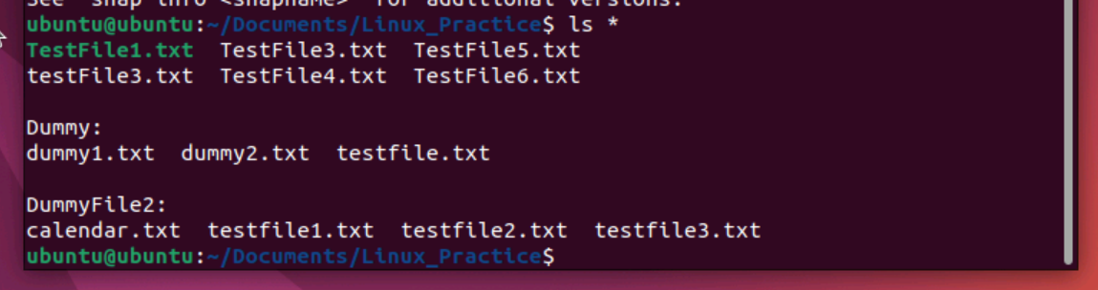

**Task 26:**

In Linux all the hidden files starts with . (period)

How to check all the hidden files in Linux..

Hint : use  ls -a

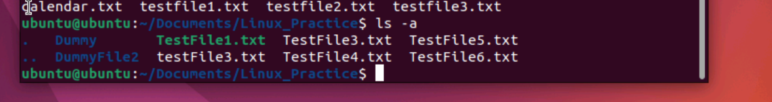

**Task 27:**

What is the difference between . and .. in linux

Line 1 line for each

Single period (.) refers to current directory

Double period(..) refers to parent directory

**Task 28:**

Can you create a file using vi editor and show the details in ss

Hint:

 Esc is for come out of the edit mode

Press two keys Shift &plus; ZZ together to come out of the file completely

* I - to insert

To move inside the file

* l key to move to the right side.
* h key to move to the left side.
* k key to move upside in the file.

j key to move downside in the file.

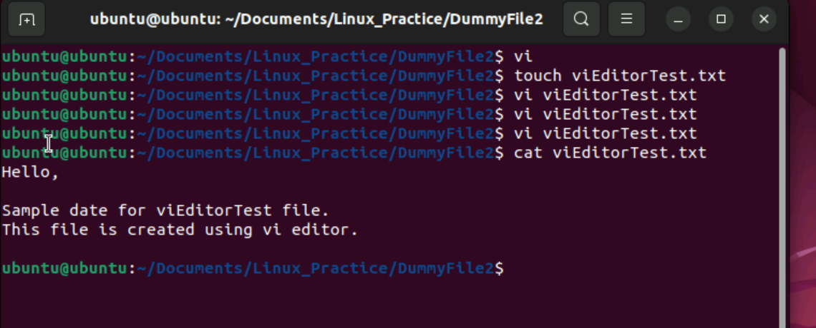

**Task 29:**

How to find the no of words in the file

Hint: use wc

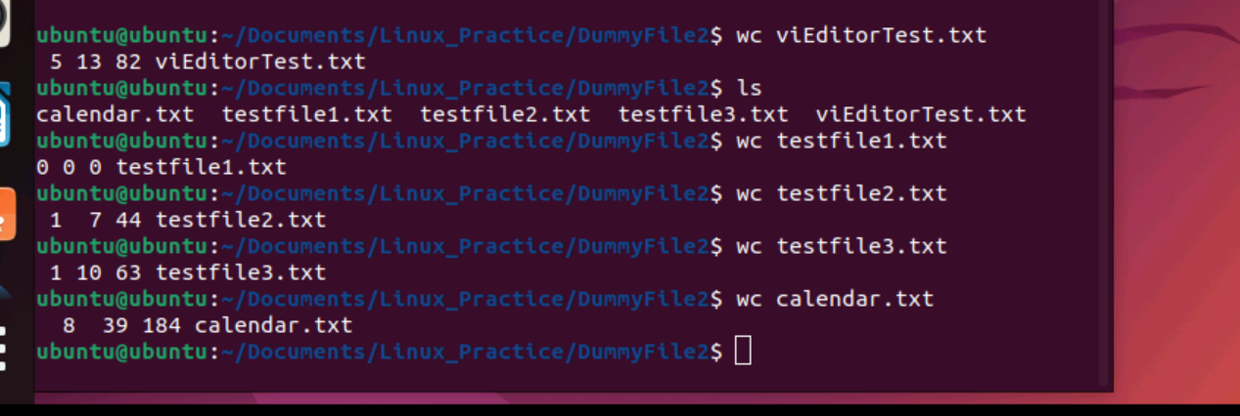

**Task 30:**

What is the use of cat -b myfilename.txt command?

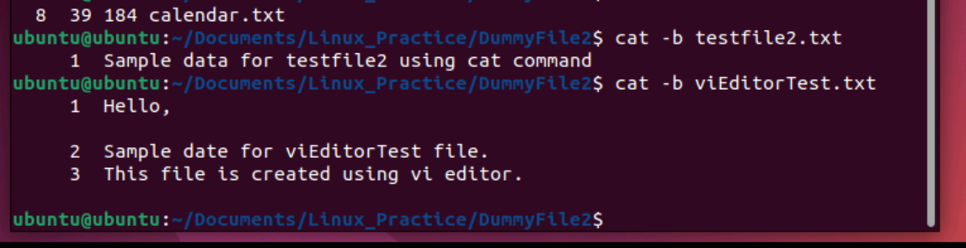

**Task 31:**

Can I use the wc with 2 or more files?

Wc file1 file2 file3

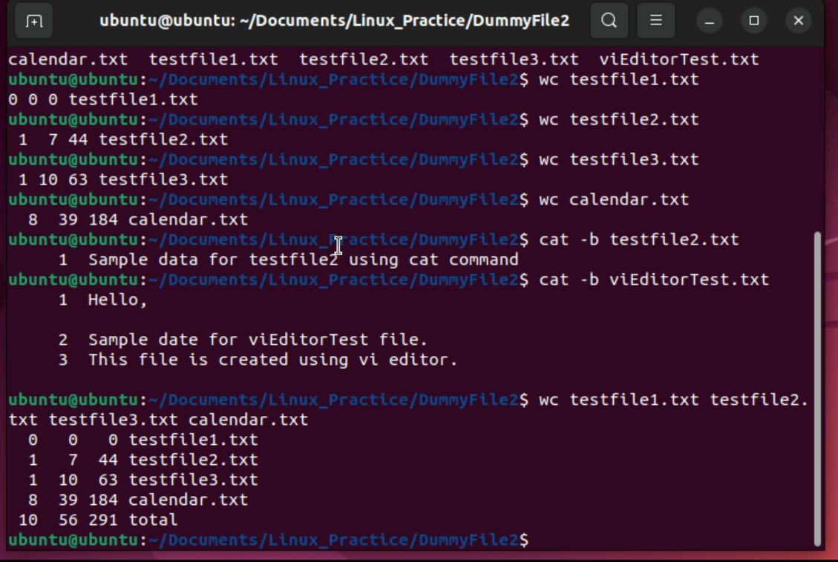

Yes we can use wc command with 2 or more files.

**Task 32:**

How to copy content of one file to another file

Hint: use cp:

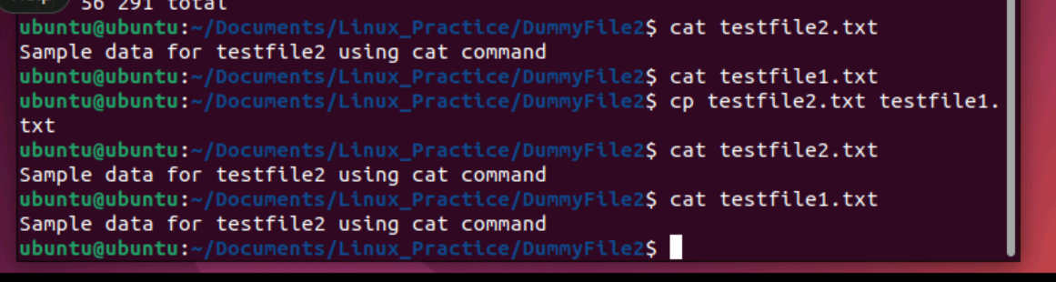

**Task 33:**

Now I want to rename my file with MYFILENEW can i do that if so how ?

Hint use : mv

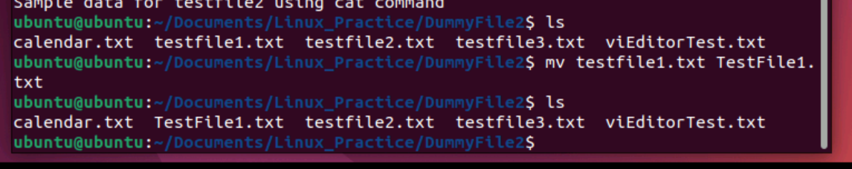

**Task 34:**

Can i remove or delete multiple files in linux..? How?

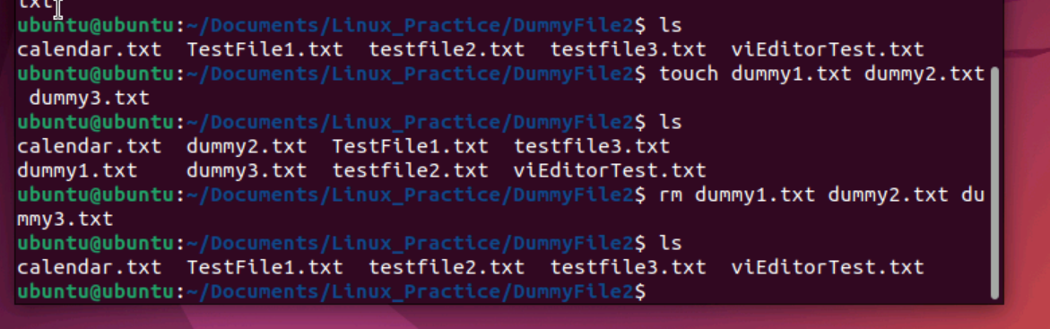

**Task 35:**

In directory / slash is root  …  can you try cd / what is it doing?

Ss plz

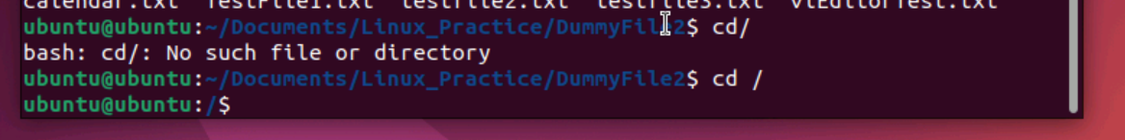

**Task 36:**

What is the way go go to home directory ?

Hint : use cd ~

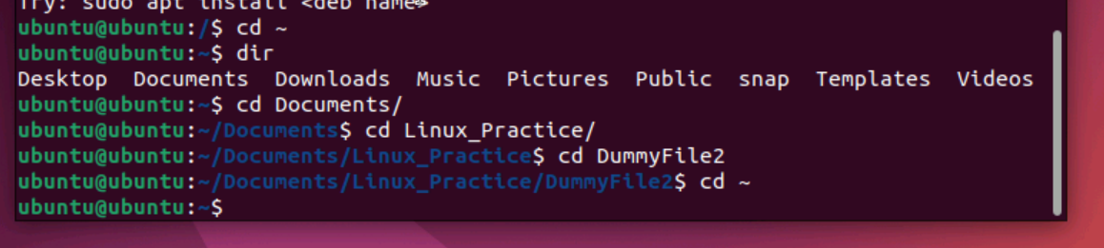

**Task 37:**

If i want to move to different users home directory

Hint : use ~username

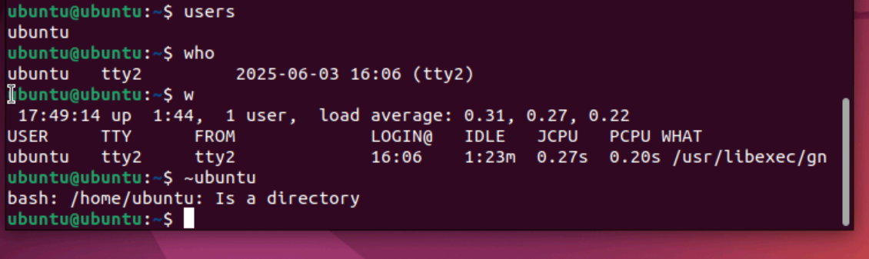

**Task 38:**

Chmods:

